Design Document: Budget Tracker

**1. Author (One-Man-Army)**

* Nischal Shrestha Kasula

**2. Functional Description**

The Budget Tracker is a desktop Java application designed to provide a simple yet effective tool for personal finance management. The application allows users to log their daily income and expenses, organize them into categories, and maintain a clear view of their overall financial standing. The core goal is to replace manual or cumbersome methods like spreadsheets with a streamlined, intuitive, and error-resistant interface.

**Key Functionalities:**  
The software will allow the user to perform the following actions:

* **Log Transactions:** Add new transactions, specifying a description, amount, category, and date. The application handles both positive values for income and negative values for expenses.
* **View Summaries:** The main screen provides a live, automatically-updated summary of Total Income, Total Expenses, and the Current Balance.
* **Manage Transactions:** Users can select any transaction from the main list to either edit its details or permanently delete it.
* **Categorize Spending:** Each transaction is assigned a category (e.g., "Food", "Income", "Utilities"), allowing for better organization and future analysis.
* **Data Persistence:** The user can save their entire list of transactions to a local file. They can also load a previously saved file to continue their session at a later time.

**Error Handling and Input Validation:**  
The application incorporates input validation to ensure data integrity:

* The **Description** field for a transaction cannot be submitted if it is empty. A warning message will prompt the user to enter a description.
* The **Amount** field uses a JSpinner component, which only allows for numeric input, preventing data entry errors.
* The **Date** field will expect a valid date format. If the input is invalid upon saving, an error message will be shown.

**Limitations:**  
This version of the application is designed as a single-user, local tool. It does not support multiple user accounts, cloud synchronization, or advanced reporting features.

**3. Graphical User Interface**

The application's interface is designed to be clean, intuitive, and efficient. It consists of two primary windows: a central dashboard for viewing data and a modal dialog for entering or editing data.

*Figure 1: The Main Dashboard Window*

The main dashboard window (see Figure 1) is the central hub. Its key features include:

* **Summary Panel:** Located at the top, three prominent labels display the most critical information at a glance: Total Income, Total Expenses, and the Current Balance.
* **Transaction Table:** A scrollable table occupies the main area, listing all transactions. It is organized into four columns: Date, Description, Category, and Amount, allowing for easy review.
* **Control Buttons:** A set of buttons at the bottom allows for primary user actions: "Add Transaction", "Edit Selected", and "Delete Selected".
* **Menu Bar:** A standard menu bar at the top provides access to file operations, including "Save" and "Load".

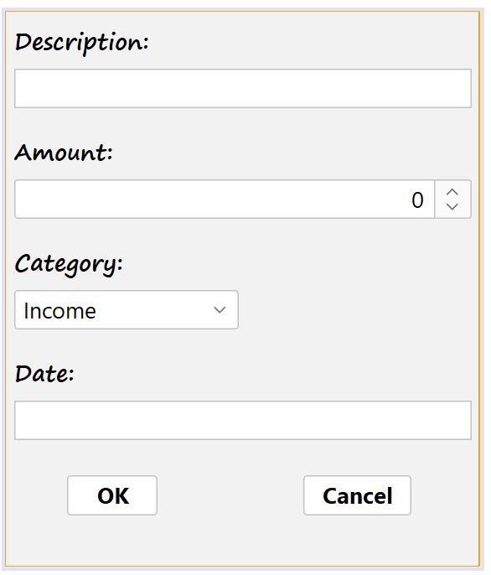  
*Figure 2: The Add/Edit Transaction Modal Dialog*

For data entry, the application uses a **modal dialog window** (see Figure 2), which is a requirement for bonus marks. This approach improves user experience by focusing the user on the single task of completing the form. It appears whenever the user clicks "Add Transaction" or "Edit Selected". Its key features are:

* **Focused Input Fields:** The dialog provides clearly labeled fields for each piece of transaction data: Description (JTextField), Amount (JSpinner), Category (JComboBox), and Date (JTextField).
* **Controlled Input:** The use of a JComboBox for categories and a JSpinner for the amount restricts user input to valid options, minimizing errors.
* **Clear Actions:** "OK" and "Cancel" buttons provide an unambiguous way to either confirm the new data or close the dialog without making changes.

**4. Current and Proposed Solutions**

* **Current Solution:** Many individuals currently track their personal finances using methods that are either overly complex or lacking in features. Common solutions include building manual spreadsheets, which are powerful but can be tedious to set up and are prone to formula errors. Other methods include using simple note-taking apps or even physical pen and paper, which offer no automation for calculations and can be easily lost or disorganized.
* **Proposed Solution:** The Budget Tracker application is proposed as a superior alternative. It provides a specialized, user-friendly interface that streamlines the entire process of financial tracking. By automating the calculation of summaries, providing controlled input forms, and integrating a simple save/load system, it removes the manual busywork and reduces the potential for user error. It offers a focused, efficient, and reliable user experience specifically tailored for personal budget management.